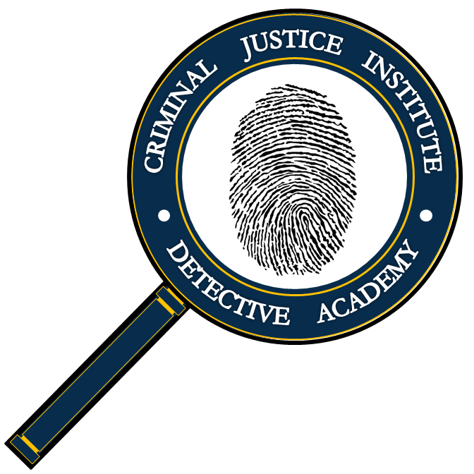**Graduation Application**

Date

**Criminal Justice Investigator Certificate**

**Complete this application, save it as “Last Name – Graduation Application,” and email it back to Krissy Faulk at kfaulk@irsc.edu.**

1. Full Name Last Four SSN

2. Agency

3. Provide the training center and date in which you completed each of the courses below.

Introduction to Investigations (40 hours) or approved substitute

Training Center Date

Interviews & Interrogations (40 hours)

Training Center Date

Case Preparation & Court Presentation (40 hours)

Training Center Date

Injury & Death Investigations (40 hours)

Training Center Date

Conducting Background Investigations (40 hours)

Training Center Date

Domestic Intervention & Investigations (40 hours)

Training Center Date

4. Recommend approval Date

Krissy Faulk - Coordinator

5. Approved Date

Pierre Pacheco - Director